Patient Information

First Name : Last Name :

Date of Birth :

Address :

Mobile : Home Phone :

Referrer Information

Name :

Practice Name :

Address :

Provider No :

Email :

Phone :

Date of request :

Reason for Referral:

___________________________________________________________________________

___________________________________________________________________________

___________________________________________________________________________

___________________________________________________________________________

___________________________________________________________________________

___________________________________________________________________________

Signature:

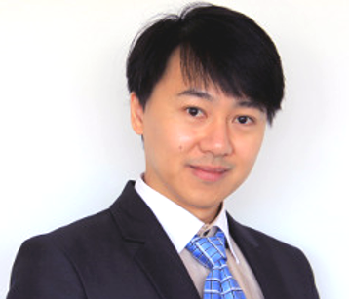**Dr Cheng Long Lu**

FRACP MBBS PGCertClinUS

Dr. Cheng Long Lu is a distinguished Respiratory, Sleep Physician and Consultant Physician.

He provides exceptional holistic healthcare, compassionate and personalised attention to patients. Graduated from the University of Melbourne, Dr. Lu further trained in the Royal Melbourne Hospital, Sir Charles Gairdner Hospital and the Royal Perth hospital. He has Fellowships in Respiratory and Sleep Medicine, as well as General and Acute Medicine.

​

As a seasoned consultant, Dr. Cheng Long Lu is renowned for accurate diagnoses, development of comprehensive treatment plans, and meticulous ongoing management of patients. His approach to patient care is of up to date best practice care, close collaboration with individuals empowering them to make informed decisions about their health.

​

Dr. Lu is the Head of the Department for Respiratory Medicine at Joondalup Health Campus. He also practices in the Mount Hospital, St John of God Subiaco and the Royal Perth Hospital.

​

Dr Lu’s field of expertise include complex respiratory diseases, sleep disorders, endobronchial ultrasound, pleural disease, tunneled pleural and ascites drainage, and general medicine.